Draw Global Execution Context for Below Codes and Explain Line by line.

console.log(a);  
var a = 10;  
console.log(a);  
a = 20;  
console.log(a);

**Explanation:**

here console.log(a); initialize undefined then var a=undefined; replace by var a=10 and initialize 10 after that var a=10 replace by var a=20 and initialize 20

|  |  |
| --- | --- |
| Memory phase | Execution phase |
| Var a=~~undefined~~  10  20 | console.log(a); undefined var a = 10;  console.log(a); 10 a = 20; console.log(a); 20 |

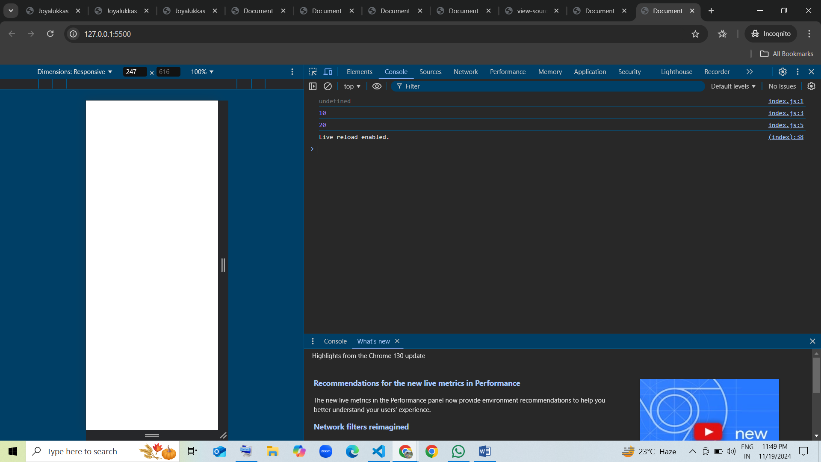

================================================================

console.log(b);  
var b = 5;  
var b = 15;  
console.log(b);  
b = b + 5;  
console.log(b);

**Explanation:**

here console.log(b); initialize undefined then var b=undefined; replace by var b=5 after that var b=5 replace by var b=15 and initialize 15, here b=b+5 b=15 already initialized so b=15 here b=15+5=20 initialize 20

|  |  |
| --- | --- |
| Memory phase | Execution phase |
| Var b=~~undefined~~  5  15 | console.log(b); undefined var b = 5; var b = 15; console.log(b); 15 b = b + 5; console.log(b); 20 |

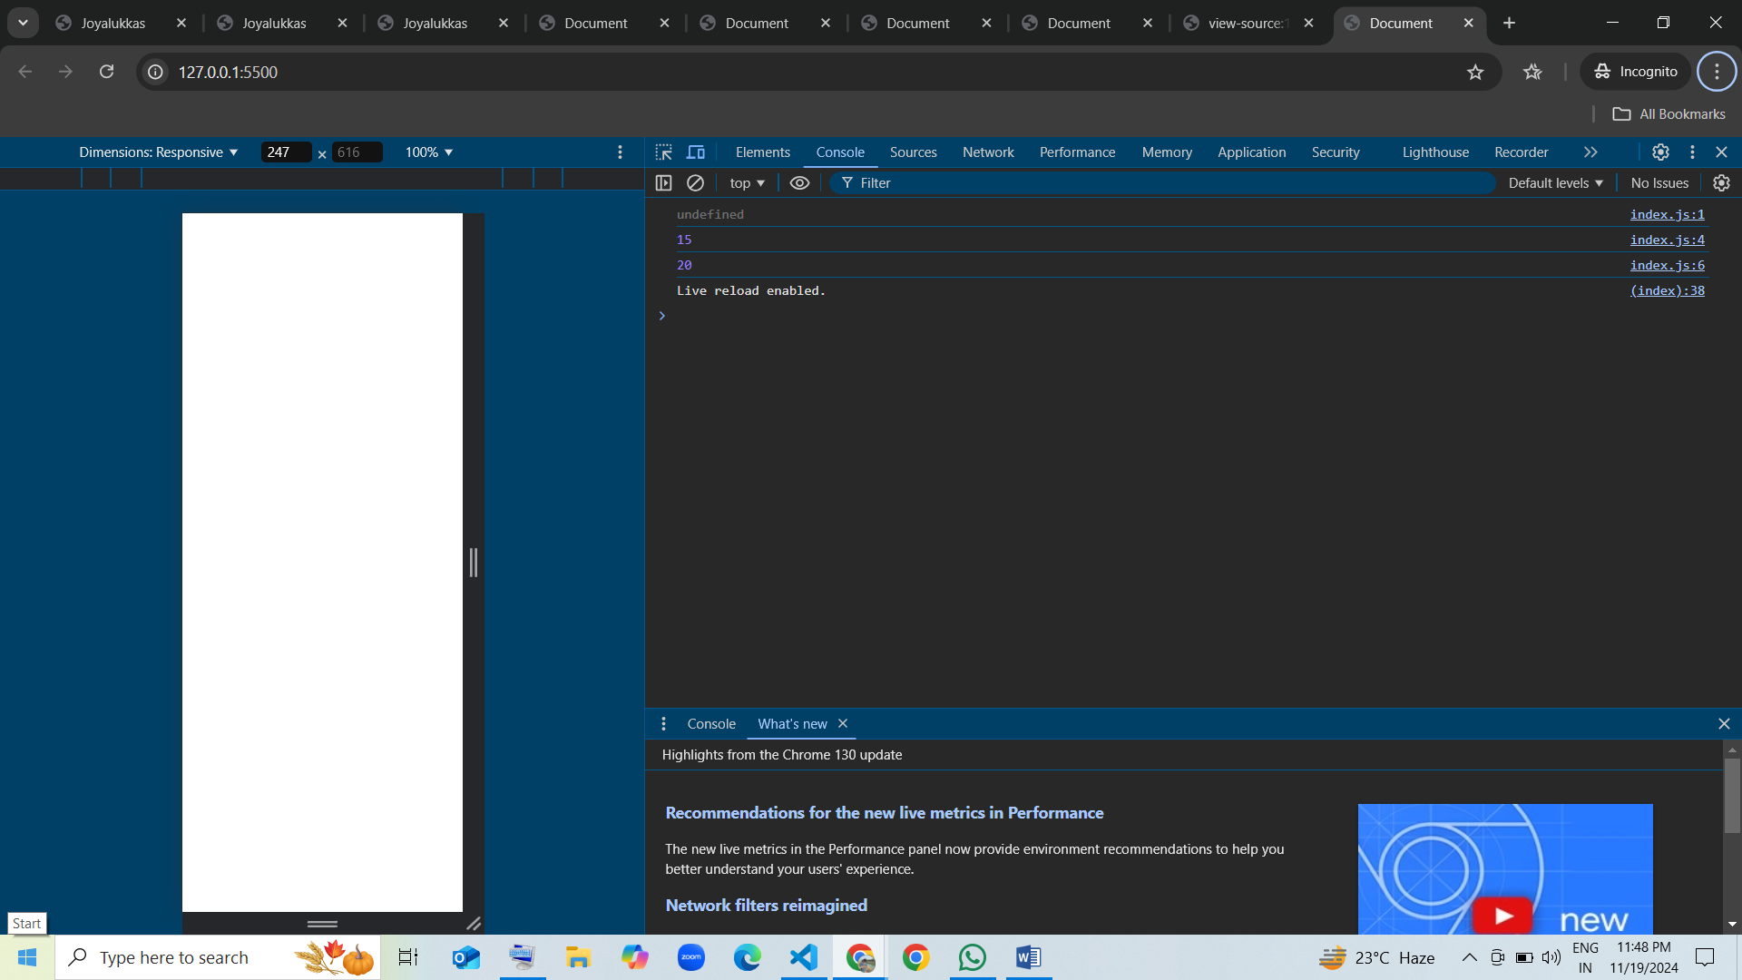

================================================================

console.log(c);  
c = 30;  
var c;  
console.log(c);  
c = c * 2;  
console.log(c);

**Explanation:**

here console.log(c);initialize undefined then var c=undefined replace by c=30 here also initilalize undefined, then var c; here it is replaced by var=30 and initialize 30 after that c=c*2 here already c initialize by 30 know c*2=30*2=60 so var c=30 replaced by var c=60

|  |  |
| --- | --- |
| Memory phase | Execution phase |
| Var c=~~undefined~~    30  30 | console.log(c); undefined c = 30; var c; console.log(c); 30 c = c * 2; console.log(c); 60 |

=================================================================

var d;  
console.log(d);  
d = 50;  
console.log(d);  
d = d + 10;  
console.log(d);  
var d = 100;  
console.log(d);

**Explanation:**

here var d; initialize undefined after assigning also initialize undefined then var d=undefined replace by d=50 here also initialize undefined, after that d=d+10 here already var d=50 initialized know d+10 is 50+10=60 after initialize var d=50 replace by var d=60 again var d=60 replace var d=100 initialize 100

|  |  |
| --- | --- |
| Memory phase | Execution phase |
| Var d=~~undefined~~    50  60 | var d; console.log(d); undefined d = 50; console.log(d); 50 d = d + 10;  console.log(d); 60 var d = 100; console.log(d); 100 |

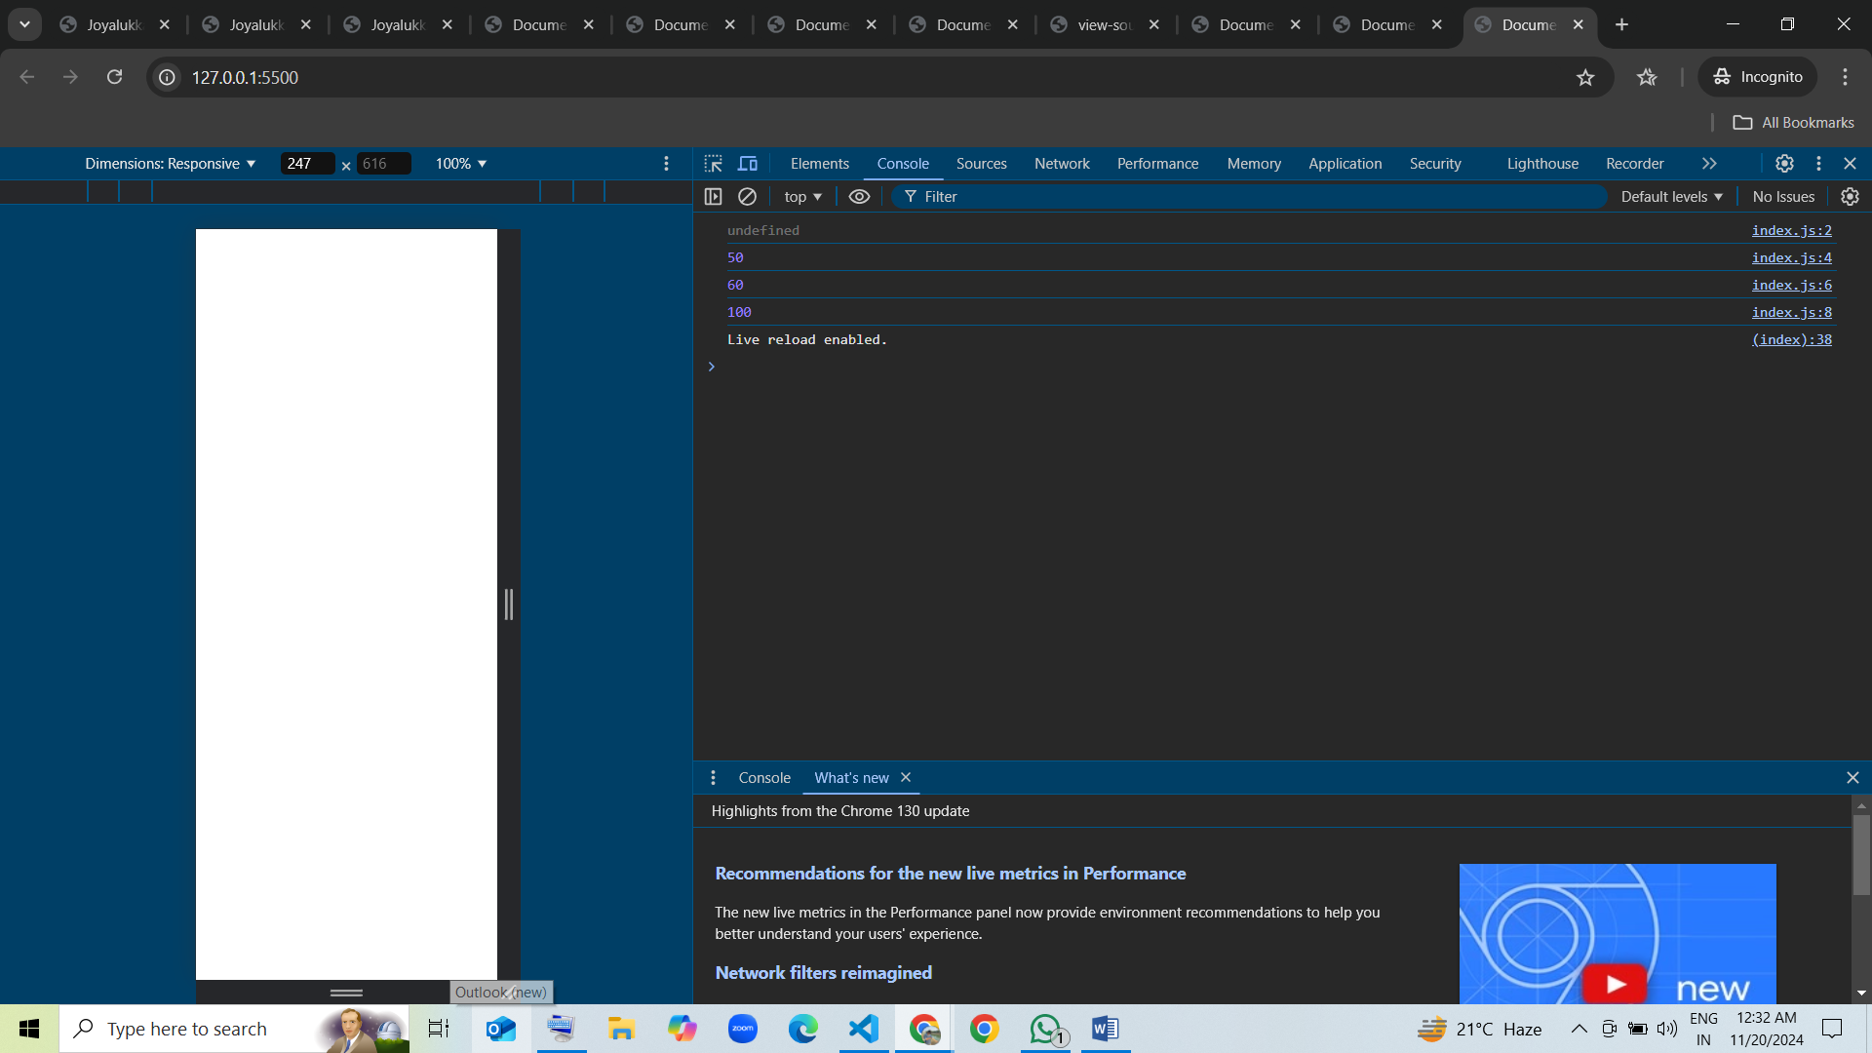

=================================================================

var e = 1;  
console.log(e);  
e = e + 1;  
console.log(e);  
var e = 10;  
console.log(e);  
e = e * 2;  
console.log(e);

**Explanation:**

here var e=1, variable declared after that here console.log(e); initialize var e=1 then e=e+1 here already e v=initialized so e=1+1 e=2 it initialize and gives 2 after that var e=2 replace by var e=10 intialize and gives 10 . here var e=10 replace by var e=e*2 var e=10 so var e=10*2 var e =20 initialize 20

|  |  |
| --- | --- |
| Memory phase | Execution phase |
| Var e=1  2  10  20 | var e = 1; console.log(e); 1 e = e + 1;  console.log(e); 2 var e = 10; console.log(e); 10 e = e * 2; console.log(e); 20 |

